API (Application Programming Interface)
An API, or application programming interface, is a set of rules or protocols that enables software applications to communicate with each other to exchange data, features and functionality. Acting as an intermediary like a waiter in a restaurant. APIs enable developers to integrate existing services, such as maps or payment processing, into their own applications without rebuilding them. APIs are mechanisms that enable two software components to communicate with each other using a set of definitions and protocols.
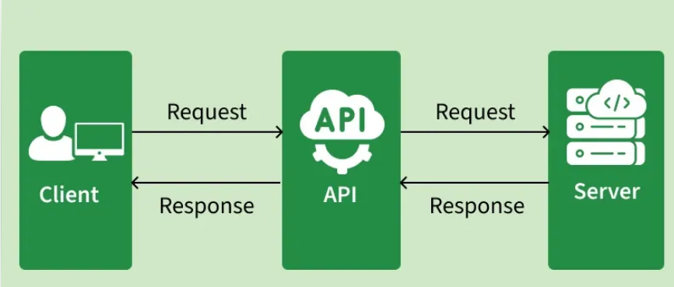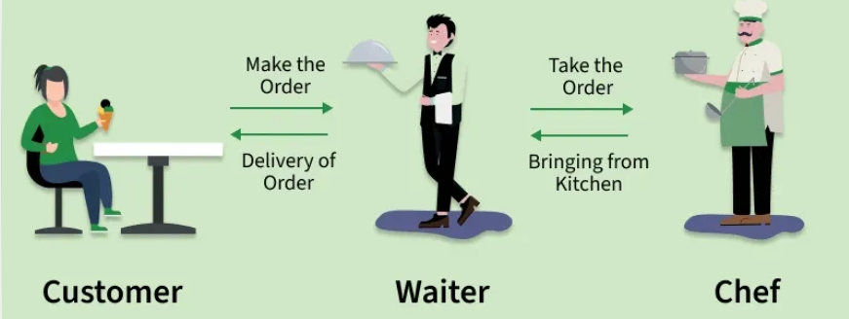
API stands for application programming interface, which is a set of definitions and protocols for building and integrating application software. APIs, or Application Programming Interfaces, are the invisible backbone of modern software development. They enable applications and systems to communicate and share data efficiently.
- Enable seamless interaction between applications, platforms, and services.
- Power everyday features such as weather updates, payments, and e-commerce checkouts.
APIs simplify and accelerate application and software development by enabling developers to integrate data, services and capabilities from other applications, instead of developing them from scratch. APIs give application owners a simple, secure way to make application data and functions available to both internal and external API consumers. API is simply a way for different systems or applications to communicate with each other.

Why Do We Need APIs?
APIs are critical to building scalable, flexible, and connected systems. Here’s why developers rely on them:
- Reusability: Avoid reinventing the wheel by leveraging existing APIs (e.g., Google Maps API, Stripe Payments API).
- Efficiency: Save development time by integrating ready made functionalities.
- Scalability: Enable modular, distributed systems that can grow easily.
- Integration: Connect multiple platforms web, mobile, IoT, or analytics.
- Automation: APIs allow machines to talk to machines without manual input.
Example: If you want to show weather updates in your app, instead of building a weather system, you can simply use the OpenWeatherMap API to fetch the data instantly.

1) Non-technical analogy
Let’s start with a non-technical analogy first. Let’s say you have a dinner reservation for tonight for three people, but you want to change it to six because some friends decided to join you at the last minute. So, you call the restaurant and ask them if it’s possible to do that. The customer service person puts you on hold. It takes a minute, but they finally come back and say yes. Simple: you called someone, made a request, and got a response yes or no.
Now, let’s say there was no customer service person, and it was up to you to figure out how many people have made reservations for the same time at the restaurant, how many tables they have free at that time, what their kitchen capacity is, and what their wait staff capacity is all to determine whether you can add three more people to your reservation. That’s a lot of unnecessary work on your part, work that you, the customer, have no expertise in. It also means the restaurant would have to reveal a lot of data to you, maybe even private data about who is eating there that night and who works there.
In this analogy, the restaurant is an application that provides a specific service or function, which is to feed you. You are an application that is trying to get fed with a group of friends. The customer service representative from the restaurant is the restaurant’s API. That is the interface through which you can communicate with the restaurant and make requests, such as changing the number on a reservation. You can do that without having to dive into the messy details of how restaurant reservations work or anything like that.

2) Technical analogy
For a more technical example, now think about Apple’s weather app. Do we think that Apple decided to set up weather monitoring stations around the world? That’s a really expensive endeavor, and if it were super critical to Apple’s business model, then maybe, sure, we could see that happening. But there are already services out there that meticulously collect global weather data, services like weather.com. So, if weather.com creates an API through which anybody can access their data, but only in the ways that weather.com allows, then Apple could just use that API to populate their weather app.
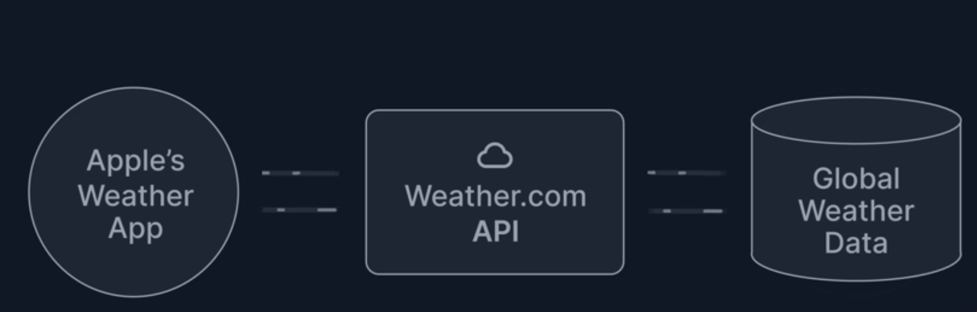

How Do APIs Work?
APIs operate through a request response cycle between a client and a server
- Request: The client sends a request to an API endpoint (URI).
- Processing: The API forwards the request to the server.
- Response: The server processes and sends back the requested data.
- Delivery: The API returns the server’s response to the client.
This communication happens over the HTTP/HTTPS protocol, with additional security via headers, tokens, or cookies.
Let’s use the example of web APIs, which are the type of APIs that deliver client requests and return responses via JSON or XML, usually over the internet. Each request and response cycle is an API call. A request typically consists of a server endpoint URL and a request method, usually through HTTP, or Hypertext Transfer Protocol. The request method indicates the desired API action.
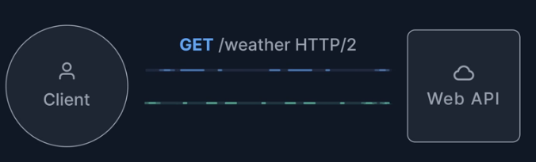
The HTTP response contains a status code, a header, and a response body. The response body varies depending on the request, and it could be the server resource a client needs to access or any application-specific messages.
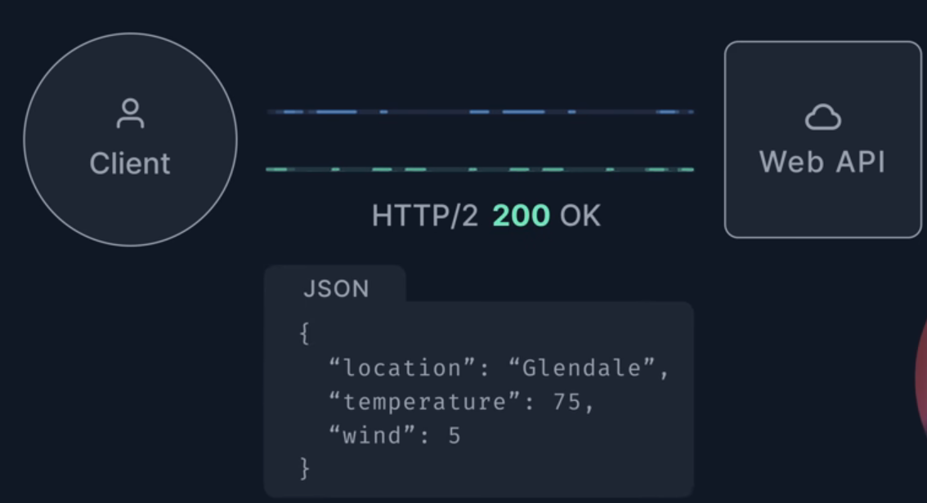
One status code you might be familiar with, especially when you have tried to visit a website that might be down or no longer exists, is the error 404 code: URL not found and that’s it request and response.

What is an API call?
An API call is a request from one application (the client) to another system’s API endpoint to retrieve or modify data. The API processes the request and returns a response, often in JSON, that includes data or a confirmation of success.
- Request: The client sends data or parameters to the API.
- Processing: The API validates, executes logic, and interacts with the server.
- Response: The API returns data, status codes, or error messages.
In short: API calls let different systems talk to each other by sending requests and receiving structured responses.
An API call (or API request) is a message sent by a client application to a server's API (Application Programming Interface) endpoint to request data or trigger a specific action. It is a way for different applications to communicate with each other the client makes the request and the server sends back a response. Each request and response cycle is an API call
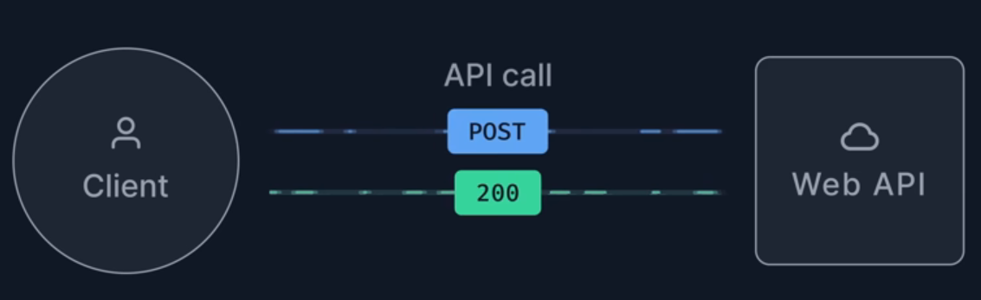
Where Does an API Call Go?
An API call goes to a specific endpoint on a server. The endpoint is a URL that is part of the API and corresponds to a resource or an action. The server processes the request and sends back a response usually in the form of JSON or XML.

How Do API Calls Work?
An API call follows a request-response cycle, typically using standard HTTP/HTTPS protocols for web APIs. When you make an API call, here’s what happens behind the scenes:
- Client Request: A client (e.g., a mobile app, web browser, or another server) sends an HTTP request to a specific API endpoint URL. The request includes key components:
- Method: Indicates the type of action to be performed like GET for retrieving data, POST for creating new data, PUT for updating existing data and DELETE for removing data.
- Endpoint: The URL to which the request is being sent. The address of the resource you’re requesting
- Headers: Provides metadata for the request, essential context and other information such as authentication credentials (like API keys or access tokens).
- Body: Contains data being sent to the server
  - Query Parameters: Optional filters appended to the URL to specify, sort, or filter the requested data (e.g., ?city=London).
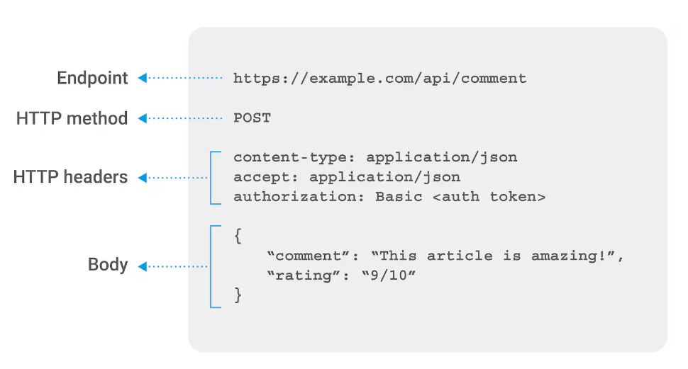
- Server Processing: The Server receives the request, validates the credentials, processes the logic (e.g., querying a database), and performs the required action.
- Server Response: The Server sends back a HTTP response to the client. This response includes
- Status Code: Indicates the success or Failure of the request like 200 OK, 400 NOT FOUND or 401 Unauthorized for authentication failure.
- Headers: Provide metadata about the response.
- Body: Contains the data being sent back to the client, typically in a structured format like JSON or XML.

How Can API Calls Be Used for an Attack?
- Injection Attacks: Attackers inject malicious code into the API request to manipulate the servers execution.
- DDoS Attacks: Attackers overwhelm the server with a high volume of requests, causing a denial of service.
- Authentication Bypass: Exploiting vulnerabilities to bypass authentication mechanisms.
- Data Exposure: Exploiting insecure endpoints to access sensitive data.
- Parameter Tampering: Modifying request parameter to gain unauthorized access or perform unauthorized actions.

How to Secure APIs from Invalid API Calls?
- Authentication and Authorization: Ensure that only authorized users can access the API.
- Input Validation: Validate all inputs to prevent injection attacks.
- Rate Limiting: Limit the number of requests a client can make in a given time period.
- HTTPS: Use HTTPS to encrypt data transmitted between the Client and server.
- API Gateway: Use an API gateway to manage and monitor API traffic.
- Error Handling: Provide informative but secure error messages.
- Token Expiry: Use token that expire after a certain period to reduce the risk of token theft
Types of API Request Method
API request methods, also known as HTTP verbs, indicate the desired action a client wants to perform on a specific resource hosted on a server. These methods are a fundamental part of the Hypertext Transfer Protocol (HTTP) and are primarily used in RESTful APIs.
The five most common API request methods are:
- GET: Retrieves data from a specified resource. This method should only be used for data retrieval and does not modify the server's state, making it a "safe" and idempotent operation.
- POST: Submits data to be processed to a specified resource, typically resulting in the creation of a new resource or causing side effects on the server. The data is sent in the request body.
- PUT: Updates a specified resource with new data or, if the resource does not exist, creates a new one. The client sends the entire updated resource in the request body, and this method is idempotent.
- PATCH: Applies partial modifications to a resource. Unlike PUT, it only requires sending the specific fields that need updating, making it more efficient for minor changes.
- DELETE: Removes a specified resource from the server. This method is idempotent, meaning multiple identical requests result in the same state as a single request.

Types of API Architectures
API architecture defines how systems communicate and exchange data, each offering different levels of flexibility, performance, and structure based on application needs. API architecture is usually explained in terms of client and server. The application sending the request is called the client, and the application sending the response is called the server.
1) REST (Representational State Transfer) APIs:
- These are the most popular and flexible APIs found on the web today. The client sends requests to the server as data. The server uses this client input to start internal functions and returns output data back to the client. REST is a simple, flexible API architecture that uses HTTP methods (GET, POST, PUT, DELETE) for communication. REST APIs are stateless, they do not save client data between requests. REST APIs use HTTP requests such as GET, PUT, HEAD and DELETE to interact with resources.
- Data Format: JSON, XML.
2) SOAP (Simple Object Access Protocol) APIs:
- SOAP is a more rigid protocol that requires XML based messaging for communication. Strict and secure protocol using XML for structured messaging. These APIs use Simple Object Access Protocol. Client and server exchange messages using XML. This is a less flexible API that was more popular in the past. SOAP is a lightweight XML-based messaging protocol specification that enables endpoints to send and receive data through a range of communication protocols including SMTP (simple mail transfer protocol) and HTTP (hypertext transfer protocol.)
- Data Format: XML
3) GraphQL APIs:
- GraphQL is a query language that was developed specifically for APIs. It prioritizes giving clients exactly the data they request and no more. It is designed to make APIs fast, flexible, and developer-friendly. As an alternative to REST, GraphQL gives front-end developers the ability to query multiple databases, microservices, and APIs with a single GraphQL endpoint. Organizations choose to build APIs with GraphQL because it helps them develop applications faster. GraphQL is an open-source query language and server-side runtime that specifies how clients should interact with APIs. GraphQL allows users to make API requests with just a few lines, rather than having to access complex endpoints with many parameters. This capability can make it easier to generate and respond to API queries, particularly more complex or specific requests that target multiple resources. Modern query language that lets clients fetch only the data they need.
- Data Format: JSON

4) RPC (Remote procedure call) APIs:
- These APIs are called Remote Procedure Calls. The client completes a function (or procedure) on the server, and the server sends the output back to the client.
5) gRPC (Google Remote Procedure Call):
- gRPC is a high-performance, open-source RPC framework initially developed by Google. gRPC uses the network protocol HTTP/2 and Protocol Buffers data format and is commonly used to connect services in a microservices architecture. High performance framework using Protocol Buffers (Protobuf). gRPC is a modern open source high performance Remote Procedure Call (RPC) framework that can run in any environment. It can efficiently connect services in and across data centers with pluggable support for load balancing, tracing, health checking and authentication. It is also applicable in last mile of distributed computing to connect devices, mobile applications and browsers to backend services.
- Data Format: Binary
6) Websocket APIs:
- Websocket API is another modern web API development that uses JSON objects to pass data. A WebSocket API supports two-way communication between client apps and the server. The server can send callback messages to connected clients, making it more efficient than REST API. WebSocket APIs enable bidirectional communication between client and server. This type of API does not require a new connection to be established for each communication, once the connection is established it allows for continuous exchange. This makes Web Socket APIs ideal for real-time communication.

Types of APIs
APIs are classified both according to their architecture and scope of use. We have already explored the main types of API architectures so let’s take a look at the scope of use. APIs are categorized based on their accessibility, usage, and purpose.
Web APIs: Accessible via the internet using HTTP. Widely used for web apps. Web APIs enable the transfer of data and functionality over the internet using HTTP protocol. Today, most APIs are web APIs. Web APIs are a type of remote API (meaning that the API uses protocols to manipulate external resources) that expose an application's data and functionality over the internet. Example: REST APIs, GraphQL APIs.
The four main types of web APIs are:
- Open APIs: Open APIs are open-source application programming interfaces you can access with the HTTP protocol. Also known as public APIs, they have defined API endpoints and request and response formats. These are open to the public and may be used by anyone. There may or not be some authorization and cost associated with these types of APIs. Example: Twitter API, GitHub API
- Partner APIs: These are only accessible by authorized external developers to aid business-to-business partnerships. Partner APIs connect strategic business partners. Typically, developers access these APIs in self-service mode through a public API developer portal. Still, they need to complete an onboarding process and get login credentials to access partner APIs. Example: Payment Gateway APIs
- Internal APIs: Internal, or private, APIs remain hidden from external users. These private APIs aren't available for users outside of the company. Instead, organizations use them to improve productivity and communication across different internal development teams. These are internal to an enterprise and only used for connecting systems and data within the business. Example: Internal microservices
- Composite APIs: Composite APIs combine multiple data or service APIs. These combine two or more different APIs to address complex system requirements or behaviors. They allow programmers to access several endpoints in a single call. Composite APIs are useful in microservices architecture where running a single task might require information from several sources.

Other types of APIs
APIs can be categorized by use case, including data APIs, operating system APIs, remote APIs and web APIs. Less common types of APIs include:
- Data (or database) APIs, used to connect applications and database management systems
- Operating system (or local) APIs, used to define how apps use operating system services and resources
- Remote APIs, used to define how applications on different devices interact

REST (Representational State Transfer) APIs
API developers can design APIs using several different architectures. APIs that follow the REST architectural style are called REST APIs. Web services that implement REST architecture are called RESTful web services. The term RESTful API generally refers to RESTful web APIs. However, you can use the terms REST API and RESTful API interchangeably. A REST API is an API that follows some principles of REST, whereas a RESTful API must follow all REST rules, including statelessness, the proper use of HTTP methods and resource-based URLs. In short, every RESTful API is a REST API, but not every REST API is RESTful. REST is an architectural design style for APIs, while HTTP is the communication protocol used for data transfer over the web. REST APIs use HTTP methods to interact with resources, but they are not the same thing. REST defines how the APIs should behave, while HTTP defines the rules for communication over the web. They commonly work together, but they serve different purposes.
REST API stands for Representational State Transfer API. It is a type of API (Application Programming Interface) that allows communication between different systems over the internet. REST APIs work by sending requests and receiving responses, typically in JSON format, between the client and server. REST APIs are stateless, which means that servers do not save client data between requests. REST APIs use HTTP requests such as GET, PUT, HEAD and DELETE to interact with resources.
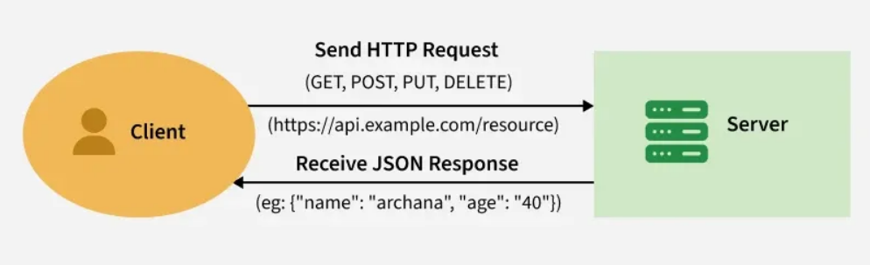

- A request is sent from the client to the server via a web URL, using one of the HTTP methods.
- The server then responds with the requested resource, which could be HTML, XML, Image, or JSON, with JSON being the most commonly used format for modern web services.
- These methods map to CRUD operations (Create, Read, Update, Delete) for managing resources on the web.

Common HTTP Methods Used in REST API
In HTTP, there are five methods that are commonly used in a REST-based Architecture, i.e., POST, GET, PUT, PATCH, and DELETE. These correspond to create, read, update, and delete (or CRUD) operations, respectively. There are other methods that are less frequently used, like OPTIONS and HEAD.
1. GET Method
The HTTP GET method is used to read (or retrieve) a representation of a resource. In the safe path, GET returns a representation in XML or JSON and an HTTP response code of 200 (OK). In an error case, it most often returns a 404 (NOT FOUND) or 400 (BAD REQUEST).
2. POST Method
The POST method is commonly used to create new resources. It is often used to create subordinate resources related to a parent resource. Upon successful creation, the server returns HTTP status 201 (Created) along with a Location header pointing to the newly created resource. POST is neither safe nor idempotent means that using the HTTP POST method to send data (e.g., submitting a form) can change the server's state (non-safe) and, if repeated, will produce multiple, different results rather than just one (non-idempotent). It is typically used for creating new, unique resources.
- Not Safe (Alters State): Unlike GET, which only retrieves dataPOST is designed to change data on the server, such as creating a new account or placing an order.
- Not Idempotent (Repetition Matters): Submitting a POST request twice will likely result in two separate actions (e.g., placing the same order twice or creating two identical user accounts).
3. PUT Method
PUT is an HTTP method used to update or create a resource on the server. When using PUT, the entire resource is sent in the request body, and it replaces the current resource at the specified URL. If the resource doesn’t exist, it can create a new one.
4. PATCH Method
PATCH is an HTTP method used to partially update a resource on the server. Unlike PUT, PATCH only requires the fields that need to be updated to be sent in the request body. It modifies specific parts of the resource rather than replacing the entire resource.
5. DELETE Method
It is used to delete a resource identified by a URI. On successful deletion, return HTTP status 200 (OK) along with a response body. DELETE method is idempotent. An idempotent HTTP method is an HTTP method that can be called many times without different outcomes. It would not matter if the method is called only once, or ten times over. The result should be the same. Again, this only applies to the result, not the resource itself.

Differences Between PUT & PATCH
Both PATCH and PUT are used to update resources on the server, but they differ in how they handle the update process:
PUT | PATCH
Replaces the entire resource | Updates only specified fields
Must send full data | Only sends changes
Idempotent | Not always idempotent
Example: Updating a user’s entire profile | Example: Changing just a user’s email

Features of REST APIs
- Stateless: Each request from a client to a server must contain all the information the server needs to fulfill the request. No session state is stored on the server.
- Client-Server Architecture: RESTful APIs are based on a client-server model, where the client and server operate independently, allowing scalability.
- Cacheable: Responses from the server can be explicitly marked as cacheable or non-cacheable to improve performance.
- Uniform Interface: REST APIs follow a set of conventions and constraints, such as consistent URL paths, standardized HTTP methods, and status codes, to ensure smooth communication.
- Layered System: REST APIs can be deployed on multiple layers, which helps with scalability and security.

Benefits of REST APIs
REST APIs offer four main benefits:
- Integration: APIs are used to integrate new applications with existing software systems. This increases development speed because each functionality doesn’t have to be written from scratch. You can use APIs to leverage existing code.
- Innovation: Entire industries can change with the arrival of a new app. Businesses need to respond quickly and support the rapid deployment of innovative services. They can do this by making changes at the API level without having to re-write the whole code.
- Expansion: APIs present a unique opportunity for businesses to meet their clients’ needs across different platforms. For example, maps API allows map information integration via websites, Android, iOS, etc. Any business can give similar access to their internal databases by using free or paid APIs.
- Ease of maintenance: The API acts as a gateway between two systems. Each system is obliged to make internal changes so that the API is not impacted. This way, any future code changes by one party do not impact the other party.

Real world Example of Rest APIs
REST APIs are widely used across various industries to simplify communication between systems. Some common applications include:
- Social media: Integrating third-party platforms like Facebook, Twitter, and Instagram for features like login, sharing, and posting.
- E-Commerce: Managing products, processing payments, handling orders, and customer management.
- Geolocation Services: GPS tracking, real-time location updates, and location-based services like finding nearby places.
- Weather Forecasting: Fetching weather data from external sources to provide real-time weather updates and forecasts.

REST vs. SOAP
SOAP and REST represent different approaches to API design, describing rules and standards for how an API should interact with other applications. SOAP is a protocol while REST is a set of constraints that constitute an architectural style. Both use HTTP to exchange information.
REST is often considered a simpler alternative to SOAP because it is lightweight, flexible, transparent and relatively easy to use; SOAP requires users to write more code to complete each task than REST requires.
SOAP is more deterministic and robust (due to type checking), and proponents make the case that it is easier to use because of the SOAP support built into many development tools.³ SOAP features built-in compliance, and developers often consider it a more secure protocol, better suited for situations with strict data integrity requirements.
RESTful systems support messaging in different formats, such as plain text, HTML, YAML, XML and JSON, while SOAP only allows XML. Each has their strengths, and the “right choice,” might depend on use case. However, the ability to support multiple formats for storing and exchanging data is one of the reasons REST is a prevailing choice for building public APIs.

REST vs. GraphQL
GraphQL is a query language and API runtime that Facebook developed internally in 2012 before it became open source in 2015. GraphQL and REST are both stateless, use a client/server model and use HTTP. GraphQL solves for some limitations of REST, for example, providing the ability to more accurately target wanted resources with a single request.
REST APIs follows a fixed structure, and always return a whole data set for a specified object. If the request is more complex, spanning multiple resources, for example, the client must submit separate requests for each resource. These limitations can lead to under or over-fetching issues.
Neither REST nor GraphQL APIs are inherently superior. They’re different tools that are suited to different tasks.
REST is generally easier to implement and can be a good choice when a straightforward, cacheable communication protocol with stringent access controls is preferred (for public-facing e-commerce sites like Shopify and GitHub, as one example).
GraphQL APIs enable more flexible, efficient data fetching, which can improve system performance and ease-of-use for developers. These features make GraphQL especially useful for building APIs in complex environments with rapidly changing front-end requirements.

Web API?
A Web API is an application programming interface for the Web. A Web API or Web Service API is an application processing interface between a web server and web browser. All web services are APIs but not all APIs are web services. REST API is a special type of Web API that uses the standard architectural style explained above. A Browser API can extend the functionality of a web browser. A Server API can extend the functionality of a web server.
Web API as the name suggests, is an API over the web which can be accessed using HTTP protocol. It is a framework that helps you to create and develop HTTP based RESTFUL services. The web API can be developed by using different technologies such as java, ASP.NET, etc. Web API is used in either a web server or a web browser. Basically Web API is a web development concept. It is limited to Web Application's client-side and also it does not include a web server or web browser details. If an application is to be used on a distributed system and to provide services on different devices like laptops, mobiles, etc then web API services are used. Web API is the enhanced form of the web application. For example, Twitter's REST APIs provide programmatic access to read and write data using which we can integrate twitter's capabilities into our own application.
The different terms around APIs, like Java API or service APIs, exist because historically, APIs were created before the world wide web. Modern web APIs are REST APIs and the terms can be used interchangeably. A web API is specifically for use by web applications that are accessed over the Internet.

Why to Choose Web API?
- A Web API services are preferable over other services to use with a native application that does not support SOAP but require web services.
- For creating resource-oriented services, the web API services are the best to choose. By using HTTP or restful service, these services are established.
- If you want good performance and fast development of services, the web API services are very helpful.
- For developing light weighted and maintainable web services, web API services are really helpful to develop that service. It supports any text pattern like JSON, XML etc.
- The devices that have tight bandwidth or having a limitation in bandwidth, then the Web API services are the best for those devices.

What is an API endpoint and why is it important?
API endpoints are the final touchpoints in the API communication system. These include server URLs, services, and other specific digital locations from where information is sent and received between systems. API endpoints are critical to enterprises for two main reasons:
1. Security
API endpoints make the system vulnerable to attack. API monitoring is crucial for preventing misuse.
2. Performance
API endpoints, especially high traffic ones, can cause bottlenecks and affect system performance.

How to secure a REST API?
All APIs must be secured through proper authentication and monitoring. The two main ways to secure REST APIs include:
1. Authentication tokens
These are used to authorize users to make the API call. Authentication tokens check that the users are who they claim to be and that they have access rights for that particular API call. For example, when you log in to your email server, your email client uses authentication tokens for secure access.
2. API keys
API keys verify the program or application making the API call. They identify the application and ensure it has the access rights required to make the particular API call. API keys are not as secure as tokens but they allow API monitoring in order to gather data on usage. You may have noticed a long string of characters and numbers in your browser URL when you visit different websites. This string is an API key the website uses to make internal API calls.

How to create an API?
Due diligence and effort are required to build an API that other developers will want to work with and trust. These are the five steps required for high-quality API design:
1. Plan the API
API specifications, like OpenAPI, provide the blueprint for your API design. It is better to think about different use cases in advance and ensure the API adheres to current API development standards.
2. Build the API
API designers prototype APIs using boilerplate code. Once the prototype is tested, developers can customize it to internal specifications.
3. Test the API
API testing is the same as software testing and must be done to prevent bugs and defects. API testing tools can be used to strength test the API against cyber attacks.
4. Document the API
While APIs are self-explanatory, API documentation acts as a guide to improve usability. Well-documented APIs that offer a range of functions and use cases tend to be more popular in a service-oriented architecture.
5. Market the API
Just as Amazon is an online marketplace for retail, API marketplaces exist for developers to buy and sell other APIs. Listing your API can allow you to monetize it.

What is API testing?
API testing strategies are similar to other software testing methodologies. The main focus is on validating server responses. API Testing ensures that APIs function as intended focusing on logic, performance, and security rather than UI. API testing includes:
- Making multiple requests to API endpoints for performance testing.
- Writing unit tests for checking business logic and functional correctness.
- Security testing by simulating system attacks.
Types of Testing:
- Unit Testing
- Integration Testing
- Security Testing
- Performance Testing
- Functional Testing

Popular API Testing Tools
Tool | Purpose
Postman | Manual and automated API testing
SoapUI | SOAP & REST API testing
JMeter | Load and performance testing
Apigee | Enterprise API management
vREST | Automated regression testing

Advantages of APIs
- Efficiency: Enable faster development using reusable components.
- Integration: Seamlessly connect different systems and services.
- Automation: Reduce manual effort by automating workflows.
- Scalability: Simplify distributed and modular system design.
- Innovation: Unlock new functionalities and integrations.
Disadvantages of APIs
- High Cost: Developing and maintaining APIs requires expertise.
- Security Risks: Exposed endpoints can be vulnerable to attacks.
- Versioning Challenges: Managing updates without breaking compatibility.
- Dependency Risk: Relying on third-party APIs introduces failure points.

API Gateway
An API gateway is a centralized software intermediary that acts as a single entry point for clients (apps, users, AI agents) to access various backend services or microservices. It manages traffic by handling routing, authentication, security, rate limiting, and request/response transformation, acting as a "traffic cop" for backend APIs.
An API Gateway is a key component in system design, particularly in microservices architectures and modern web applications. It serves as a centralized entry point for managing and routing requests from clients to the appropriate microservices or backend services within a system.
- An API Gateway serves as a reverse proxy between clients and backend services.
- After receiving incoming client requests, it manages a number of responsibilities, including rate limitation, routing, and authentication, before forwarding the requests to the appropriate backend services.
- Offers a consistent interface and hiding the complexity of the underlying architecture
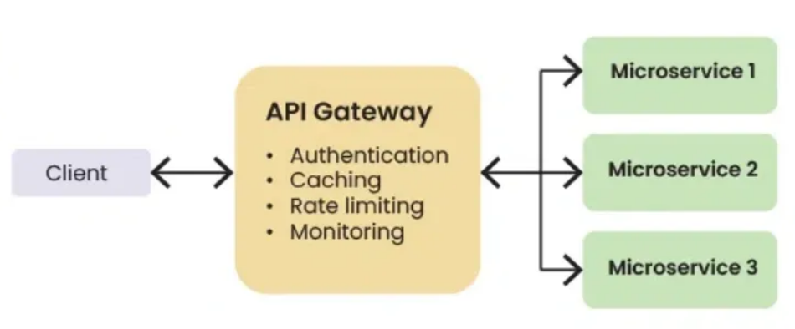
The primary purpose of an API Gateway is to simplify the client's interaction with the underlying services, enhance security, and provide various features for managing and monitoring API traffic.
An API Gateway is an API management tool for enterprise clients that use a broad range of back-end services. API gateways typically handle common tasks like user authentication, statistics, and rate management that are applicable across all API calls.
Amazon API Gateway is a fully managed service that makes it easy for developers to create, publish, maintain, monitor, and secure APIs at any scale. It handles all the tasks involved in accepting and processing thousands of concurrent API calls, including traffic management, CORS support, authorization, and access control, throttling, monitoring, and API version management.

API gateway is used for authentication and rate limiting

Load Balancer Vs API Gateway
Info from Teams chat
Sonar is an open-source platform for continuous inspection of code quality. It performs static code analysis and provides detailed reports for bugs, vulnerabilities, code smells (source code characteristics, which possibly indicate a deeper problem), and code duplications.
SonarQube supports the most common programming languages used in Sabre: JavaScript, Java, C/C++, Python and Groovy.

IQ Server is the policy engine that we use at Sabre. It provides multiple tools, which can be used for identifying third-party dependencies and vulnerabilities in application components. It works by scanning artifacts for security vulnerabilities before promotion to our Nexus Trusted Repositories. Integral part of Sabre CI/CD platform.

Promotion Jenkins: It is as integral part of Sabre CI/CD platform used for prmoting deployable artifacts from Nexus staging repositories to Nexus trusted repositories. Promotion process is taking care of following tasks:
- security scan with IQ server
- Artifact move to respective Nexus trusted repositories.

Jira: Jira is the Defect Tool of Record for Sabre and is used to track customer and internally reported issues for various business units across Sabre. Jira is used by Sabre’s Engineering, Technology, Product, and CARE/Support organizations. Jira may be accessed via URL https://ptjira.sabre.com. With the migration to Google Cloud Platform, Jira will utilize Single Sign-On (SSO).

Armada: Armada is a web-based tool, which is responsible for orchestrating automated application changes in all Sabre environments - Production (Prod), Certification (Cert) and Development (Dev). It is fully integrated with our ticketing system, ServiceNow (SNOW).
You can access Armada’s UI, by navigating to the following URL: https://armada.sabre-gcp.com. Use Armada to manage your NGP (Next Generation Platform) and GCP (Google Cloud Platform) applications.
ServiceNow

Workflow
You can use Armada to move an application from one environment to another, or promote it to higher environment, while keeping its configuration. To do that, your application must be registered in Armada, and the change request must be approved in ServiceNow (SNOW).

Dynamic Host Configuration Protocol (DHCP) is a network management protocol that automatically assigns IP addresses, subnet masks, default gateways, and DNS server details to devices. It eliminates manual configuration, preventing IP conflicts and simplifying network administration for both small and large networks.
Dynamic Host Configuration Protocol
The Dynamic Host Configuration Protocol (DHCP) is a network management protocol used on Internet Protocol (IP) networks for automatically assigning IP addresses and other communication parameters to devices...

Cloud Workstation: Fully managed development environments built to meet the needs of security-sensitive enterprises. It enhances the security of development environments while accelerating developer onboarding and productivity, including a native integration with Gemini for Google Cloud.
Google Cloud Workstations (GCW) is a managed development environment service running on Google Cloud Platform. Think of it as a virtual Linux development machine in the cloud — pre-configured, always available, and accessible from anywhere via SSH or a web browser.
Instead of running your development environment locally on your laptop (via WSL, VMs, or native Linux), you connect to a remote machine hosted in Google’s infrastructure. Your code, tools, and configuration live there — your laptop becomes just a thin client.

3 way hand shake in networking? microservice communication, networking

A networking handshake is an automated, multi-step negotiation process between two devices (e.g., client and server) that establishes a secure, reliable communication channel before actual data transmission begins. It synchronizes connection parameters like sequence numbers and ensures both parties are ready to exchange data.
Key Aspects of the TCP 3-Way Handshake
- SYN (Synchronize): The client sends a packet to the server to initiate a connection.
- SYN-ACK (Synchronize-Acknowledgment): The server replies with a packet confirming receipt and willingness to connect.
- ACK (Acknowledgment):
Purpose and Benefits
- Reliability: Ensures both parties are synchronized and ready for communication.
- Security: Handshake protocols (like SSL/TLS) are used to authenticate identities and agree on encryption methods.
- Error Prevention: Detects issues and prevents data loss by synchronizing sequence numbers.
- Parameter Negotiation: Sets up rules for communication, such as data transfer rates.
Types of Handshakes
- TCP Handshake: The standard 3-step process (SYN, SYN-ACK, ACK) for establishing IP-based network connections.
- SSL/TLS Handshake: Used for HTTPS connections, ensuring data is encrypted and the server is trustworthy.
- Four-way Handshake: Typically used to terminate a connection.
The client sends a final confirmation packet back to the server, establishing the connection.
Handshake
In computing, a handshake is a process in which two devices establish a communication link by authenticating and validating each other's signals. An example is the handshaking between a hypervisor ...

TCP uses a process called 3-way Handshake for reliable communication. In 3-way Handshake process, three TCP segments are exchanged between the sender and the receiver to establish a reliable connection. These are called SYN, SYN-ACK and ACK.

TLS Handshake

